**Supporting Information**

**From cave geomorphology to Palaeolithic human behaviour: speleogenesis, palaeoenvironmental changes and archaeological insight in the Atxurra-Armiña cave (northern Iberian Peninsula)**

By M. Arriolabengoa, I. Intxaurbe, M.A. Medina-Alcaide, O. Rivero, J. Rios-Garaizar, I. Libano, P. Bilbao, A. Aranburu, H. Cheng, R. Laurence Edwards, D. Garate.

**Context**

*Atxurra-Armiña cave description*

The lower cave level (Armiña) is the shorter of the two, and the levels are connected by two steeply-sloping passages (Fig. 2). The first connection shaft is located near the current entrances of the two cave levels, and is a steep slide, 1 m wide. The second connection passage is situated at the end of the lower cave level, and is formed by a collapse of the intermediate rock, partly due to the fact that this area is crossed by the stratigraphic limestone with siliceous nodules, causing a rockfall from the stratigraphic bedding (Fig. 3a). This bed is almost 4 to 6 meters thick, and crosses part of the upper cave level before the connection, causing the ceiling of this passage to have collapsed as well (Fig. 2). Both cave levels are characterized by a relatively horizontal floor, in which fine clastic sediments alternate with flowstones. Currently, only a few parts of these flowstones are active in both cave levels (Fig. 2). Apart from two crawlway passages of 40 – 60 cm in height, one on each cave level, the rest of the cave is almost perfectly walkable. According to Arriolabengoa et al. (2018), based on geomorphological and sedimentological features the cave is differentiated in three parts:

*Outer Atxurra*

Its floor is relatively horizontal. At the entrance there is a sedimentary fill of at least 2 m, containing archaeological and palaeontological remains (Rios-Garaizar et al., 2019), but as the passage reaches the first connection loop to the lower cave level, the floor is represented by a currently inactive extensive flowstone. This flowstone ends after a crawlway, followed by a passage with the floor composed of fine clastic sediments. Just after this crawlway, there is a deposit of bat guano produced mainly by *Rhinolophus ferrumequinum* and *Rhinolophus euryale* (Balcells and Gracia, 1962). The final part of the gallery floor is characterized by dens of cave bears, and before reaching the second connection with the lower cave level, the roof has partially collapsed along bedding partings.

*Inner Atxurra*

The floor extends horizontally to the end of the cave, with fine sediments intercalating with flowstone formation, currently active during the wettest periods. The roof is located between 6 and 10 meters above the floor, and where the vadose speleogenesis has not overprinted earlier forms, it is characterized by a ceiling channel. The passage is 2 – 4 m wide, and is covered by horizontally-developed decimetric to metric notches (Fig. 3f). There is a continuous notch of 1 m in height and 0.4-0.9 m in depth along the entire passage, situated at a height of between 2 – 2.3 m above the passage floor. On the part of the wall above this notch, there are morphologies such as pendants and anastomotic bedding planes, which are related to the phreatic zone, and a speleogenesis by paragenetic processes. These notches are likely to have been formed either by paragenetic speleogenesis as or by a vadose stream (Pasini, 2012), although the implications are entirely different in each case. Probably because the width of the conduit is too great, we were unable to identify the meander migration vector, which would have enabled us to determine whether the entire gallery was formed under paragenetic conditions or by alluvial processes (Lauritzen and Lauritsen, 1995).

*Armiña cave level*

As with the other two parts, the Armiña cave level has a horizontal cave floor that intercalates fine clastic sediments and flowstone speleothems, the latter of which are currently active. The general morphology of the passage is almost the same throughout the cave level, but there are differences at two points. One is at the entrance, where there are at least two colluvial cones of matrix-supported heterogeneous clastic sediments filling the passage from the outside (Fig. 2). Both sedimentary bodies are covered by a thin flowstone, which is currently inactive. The present entrance of Armiña has similar morphologies; however due to work to expand the road outside, this entrance was cut and uncovered. The second point is at the end of the passage, prior to the connection with the upper cave level, where the passage becomes a crawlway due to the lowering of the cave roof and the rise in the cave floor due to flowstone formation, reducing the available space. Apart from for these two points, the passage is between 3 and 5 m high and 3 to 4 meters wide. At the entrance there is evidence of sporadic human occupation from the Upper Magdalenian cultural period, suggesting that this entrance was closed at that time, with humans entering from the upper gallery entrance (Rios-Garaizar et al., 2020).

**Methods**

*Cave 3D model*

This model was made using a 3D Faro Photon 120 Terrestrial Laser Scanner, allowing us to work without causing additional damage to such a sensitive environment and its cultural heritage. The 3D model also enabled us to take different measurements throughout the geomorphological and sedimentological units, as well as measuring the dimensions of the cave passage.

*Speleothem sampling, thin section making and dating*

Sampling was performed based on the proposed stratigraphic schema and the availability of suitable samples (access to samples without disturbing rock art, crystal quality, etc.), using a Pointet-Tip Hammer with a rock chisel or coping hand saw. Thin sections of the samples were taken at the University of the Basque Country’s research facilities (SGIker), in order to choose the least altered and most closed crystal systems (Frisia, 2015)⁠. Thin sections were studied using an Olympus BH2 petrographic microscope equipped with an Olympus DP10 digital camera and Nikon Elements imaging software. The speleothems were sampled by Dremel Fortiflex (9100-21) drilling with a diamond wheel (2 mm diameter in the thickest part). From each sample 0.2 g was extracted.

The 230Th dating work was performed at the Isotope Laboratory, Xi’an Jaiotong University using multi-collector inductively coupled plasma mass spectrometers (MC-ICP-MS) (Thermo-Finnigan Neptune-plus). We used standard chemical procedures to separate U and Th for dating (Edwards et al., 1987). A triple-spike (229Th–233U–236U) isotope dilution method was used to correct for instrumental fractionation and determine U-Th isotopic ratios and concentrations. The instrumentation, standardization and half-lives are reported in Cheng et al. (2000) and (2013). All U-Th isotopes were measured on a MasCom multiplier behind the retarding potential quadrupole in the peak-jumping mode. We followed similar procedures for characterizing the multiplier as described in Cheng et al. (2000). Uncertainties in U-Th isotopic data were calculated offline at 2σ level, including corrections for blanks, multiplier dark noise, abundance sensitivity, and contents of the same nuclides in spike solution. Corrected 230Th ages assume an initial 230Th/232Th atomic ratio of 4.4 ±2.2 x10-6, the values for material at secular equilibrium with a bulk earth 232Th/238U value of 3.8.

**Results**

*Sampled and dated speleothem petrology*

The described main microfacies are resumed in Fig. S1.

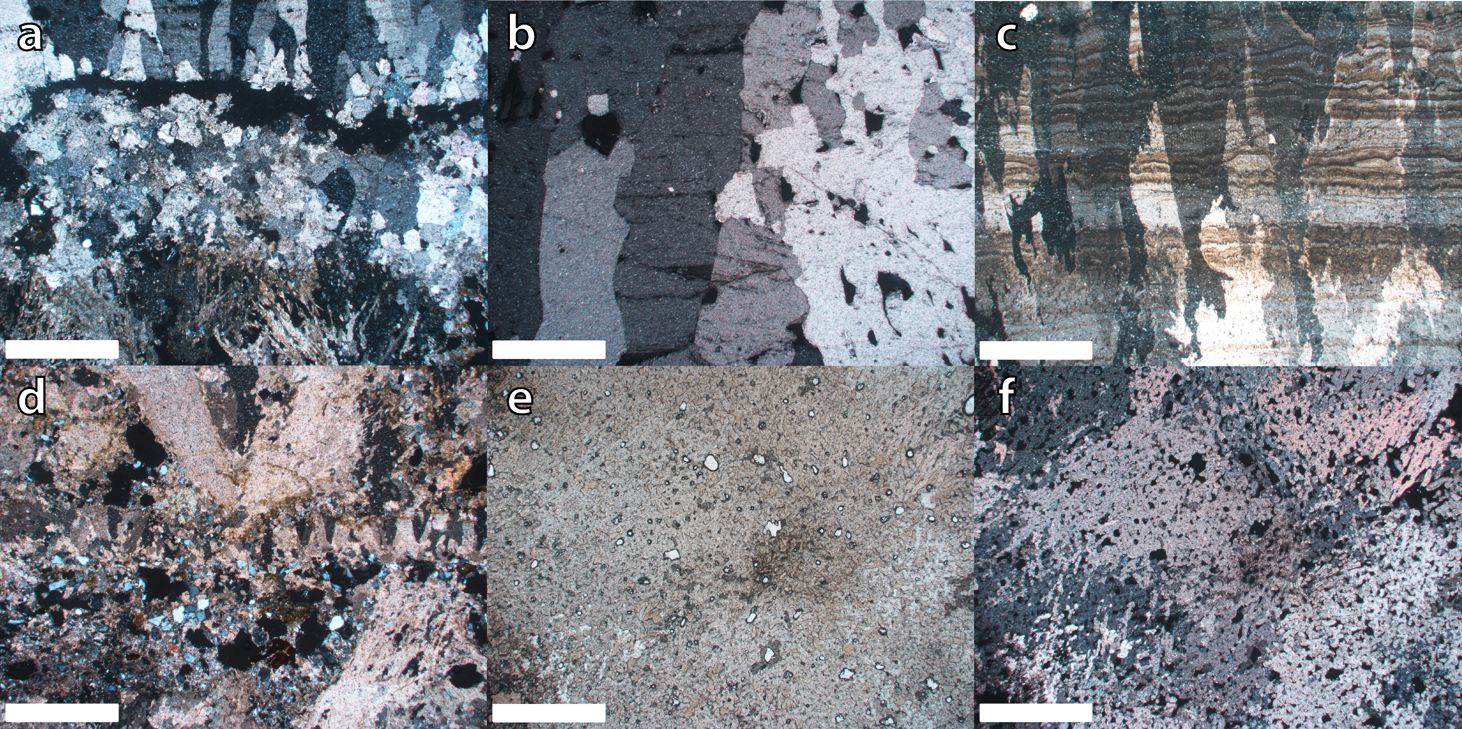

**Fig. S1.** Microphotographs of dated speleothems: a) Sample ATX-2, the boundary between the dendritic fabric and open columnar fabric, characterized by a mosaic calcite; b) Sample ATX-5 characterized by an open columnar fabric; c) Sample ATX-3A characterized by a columnar microcrystalline fabric; d) Sample ATX-11 dendritic fabric with some intercalated grains of quartz; e) Sample ATX-10 showing mosaic sparite crystals with high porosity fabric; f) Same as e) but under XPL. The white bar at the bottom indicates 1 mm scale.

**References**

Arriolabengoa M, Intxaurbe I, Bilbao P et al., 2018. Geomorfología de la cueva Atxurra-Armiña (Berriatua, Bizkaia). In: García C, Gómez-Pujol L, Morán-Tejeda E, Batalla R.J. (eds.), Geomorfología del Antropoceno. Efectos del Cambio Global sobre los procesos geomorfológicos. Universitat de les Illes Balears, Sociedad Española de Geomorfología, Palma, 95-98.

Balcells E. Gracia, J 1962. Murciélagos cavernícolas del País Vasco-Navarro: Campaña 1958-60. Speleon, 14, 33-63.

Cheng H, Edwards, RL, Hoff J, et al. 2000. The half-lives of U-234 and Th-230. Chemical Geology 169, 17–33.

Cheng H, Edwards RL, Shen CC, et al. 2013. Improvements in 230Th dating, 230Th and 234U half-life values, and U–Th isotopic measurements by multi-collector inductively coupled plasma mass spectrometry. Earth and Planetary Science Letters 371, 82–91.

Edwards RL, Chen JH, Wasserburg GJ 1987. 238U, 234U, 230Th, 232Th systematics and the precise measurement of time over the past 500,000 years. Earth Planetary Science Letters 81, 175–192.

Lauritzen S, Lauritsen A, 1995. Differential diagnosis of paragenetic and vadose canyons. Cave and karst Science 21, 55–59.

Pasini G, 2012. Speleogenesis of the “Buco Dei Vinchi” Inactive Swallow Hole (Monte Croara Karst Sub-Area, Bologna, Italy), an Outstanding Example of Antigravitative Erosion (or “Paragenesis”) in Selenitic Gypsum. An Outline of the “Post-Antigravitative Erosion.” Acta Carsologica 41, 15–34.

Rios-Garaizar J, San Emeterio A, Larrea Robles M, et al. 2019. The prehistoric sequence of Atxurra cave (Berriatua, Biscay): review of J.M. Barandiarán Ayerbe excavations (1934 – 1935). Munibe 70, 21-34.

Rios-Garaizar J, San Emeterio A, Arriolabengoa M, et al. 2020. Sporadic occupation in Armiña cave during the Upper Magdalenian: what for? Journal of Archaeological Science: Reports 30, 102271.